1.EDUGENIE – GOOGLE GEMINI POWERED AI LEARNING ASSISTANT

EduGenie is an intelligent web-based learning assistant designed to simplify studying by providing AI-generated explanations, quizzes, and summaries using Google Gemini technology.

2. PROJECT DESCRIPTION
System Overview
EduGenie is a Generative AI-powered educational web application that acts as a virtual learning assistant for students. The system allows users to ask academic questions, generate quizzes for practice, and summarize lengthy study material into concise points. The goal is to make learning interactive, accessible, and stress-free.
Problem Domain
Many students face difficulty understanding complex concepts, organizing study materials, and preparing for exams efficiently. Traditional learning platforms provide static content and lack personalization. EduGenie solves this by offering dynamic, AI-generated explanations tailored to user input.
Core Technology Used
- Python Flask for backend processing
- HTML, CSS for frontend interface
- Google Gemini Generative AI API
- RESTful communication between frontend and backend
Key Capabilities
- Concept explanation in simple language
- Automatic quiz generation
- Smart summarization of notes
- Interactive user interface
- Structured AI responses
Target Users
- College and school students
- Self-paced learners
- Online education users
- Exam preparation students
Real-world Relevance
AI-assisted education is becoming a major trend worldwide. Tools like EduGenie support personalized learning and reduce dependency on traditional tutoring methods.

3. APPLICATION SCENARIOS / USE CASES
- Educational Learning
Students can ask doubts anytime and receive clear explanations instantly.
- Exam Preparation
Learners generate quizzes to test their understanding before exams.
- Quick Revision
Long notes or articles can be summarized into key exam points.
- Self-learning Support
Independent learners use EduGenie as a digital mentor for continuous learning.

4. TECHNICAL ARCHITECTURE OVERVIEW
Frontend Layer
The frontend is built using HTML, CSS. It provides a clean interface with tabs for asking questions, generating quizzes, and summarizing notes. User inputs are collected and sent to the backend using API requests.
Backend Layer
The backend is developed using Flask. It handles incoming requests, validates inputs, communicates with the Gemini API, and sends responses back to the frontend.
Database Layer
No database is used because responses are generated dynamically by AI and do not require permanent storage.
External APIs / Services
Google Gemini API performs natural language understanding and content generation.
Deployment Environment
The system runs locally using Flask’s development server and can later be deployed to cloud platforms.
Data Flow
User Input → Frontend Request → Flask Backend → Gemini API → Response Processing → Display Output

5. PREREQUISITES
5.1 Software Requirements
- Python 3.x
- Visual Studio Code or similar IDE
- Modern web browser (Chrome/Edge)
- Internet connection
5.2 Libraries / Frameworks / Dependencies
- Flask – web framework
- Google GenAI – Gemini API integration
- Python-dotenv – environment variable management
5.3 Hardware Requirements
- Minimum 4GB RAM
- Dual-core processor or higher
- Internet connectivity
- Standard desktop/laptop system

6. PRIOR KNOWLEDGE REQUIRED
Before implementing this project, the following concepts are helpful:
- Python programming fundamentals
- Basics of web development
- API request-response model
- Cloud-based AI services
- Introduction to Generative AI concepts

7. PROJECT OBJECTIVES
Technical Objectives
- Build a functional AI-powered web application.
- Integrate Google Gemini API efficiently.
- Implement multiple AI learning features.
Performance Objectives
- Provide fast and reliable responses.
- Maintain smooth UI interaction.
Deployment Objectives
- Enable easy setup and execution locally.
- Prepare system for future cloud deployment.
Learning Outcomes
- Understanding API integration
- Full-stack development experience
- Practical application of Generative AI

8. SYSTEM WORKFLOW
- User selects a feature (Ask, Quiz, Summarize).
- User enters input text.
- Frontend validates input.
- Request sent to Flask backend.
- Backend processes request.
- Gemini API generates response.
- Result formatted and displayed.
- User interacts with output (quiz scoring or reading results).

9. MILESTONE 1: REQUIREMENT ANALYSIS & SYSTEM DESIGN
9.1 Problem Definition
Students require a smart assistant capable of explaining topics, creating assessments, and summarizing study material automatically.
9.2 Functional Requirements
- Accept user queries
- Generate AI explanations
- Create quizzes dynamically
- Summarize educational content
- Display results interactively
9.3 Non-Functional Requirements
- User-friendly interface
- Quick response time
- Secure API usage
- High reliability
9.4 System Design Decisions
- Flask chosen for lightweight backend.
- Stateless architecture used.
- AI processing outsourced to Gemini API.
9.5 Technology Stack Selection Justification
Flask simplifies backend creation, Gemini provides powerful AI generation, and web technologies ensure accessibility without installation.\

10. MILESTONE 2: ENVIRONMENT SETUP & INITIAL CONFIGURATION
10.1 Development Environment Setup
Python environment configured and project folders organized for frontend and backend development.
10.2 Dependency Installation
pip install flask google-genai python-dotenv
10.3 Project Structure Creation
Separate folders created for templates and static files to maintain clean architecture.
10.4 Configuration Setup
API keys stored securely using .env file to prevent exposure.

11. MILESTONE 3: CORE SYSTEM DEVELOPMENT
11.1 Feature 1 – Ask EduGenie
Allows students to ask questions and receive structured explanations generated by Gemini AI.
11.2 Feature 2 – Interactive Quiz Generator
Creates multiple-choice quizzes with automatic scoring and answer validation.
11.3 Feature 3 – Study Material Summarizer
Transforms long paragraphs into concise bullet-point summaries useful for revision.

12. MILESTONE 4: INTEGRATION & OPTIMIZATION
12.1 Component Integration
Frontend JavaScript connected with Flask routes using fetch API.
12.2 Performance Optimization
- Reduced unnecessary requests
- Efficient response handling
12.3 Security Enhancements
- Environment variable protection
- Input validation checks
12.4 Error Handling & Validation
Handles empty inputs, API errors, and connection failures gracefully.

13. MILESTONE 5: TESTING & VALIDATION
13.1 Test Cases
Test Case | Input | Expected Output | Status
Ask Feature | Question | Explanation | Pass
Quiz Feature | Topic | Quiz Generated | Pass
Summary Feature | Notes | Summary | Pass
13.2 Unit Testing
Each API endpoint tested individually.
13.3 Integration Testing
Frontend and backend communication verified.
13.4 User Acceptance Testing
Students tested usability and clarity of responses.
13.5 Performance Metrics
- Fast response generation
- Smooth UI rendering
- Stable API interaction

14. DEPLOYMENT
14.1 Deployment Architecture
Browser → Flask Application → Gemini API → Response → Browser
14.2 Hosting Platform
Currently runs locally(VS code)
14.3 Deployment Steps
- Install dependencies
- Add API key
- Run: python app.py
14.4 Production Considerations
- Secure API keys
- Enable HTTPS
- Add authentication system

15. PROJECT STRUCTURE
- project_root
│
├── static → CSS and assets
├── templates → HTML files
├── app.py → Backend logic
├── requirements.txt
└──.env → API configuration

16. RESULTS
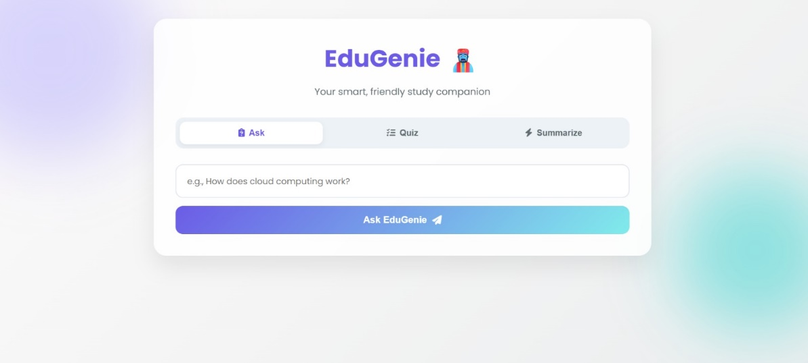
Fig: EduGenie User interface
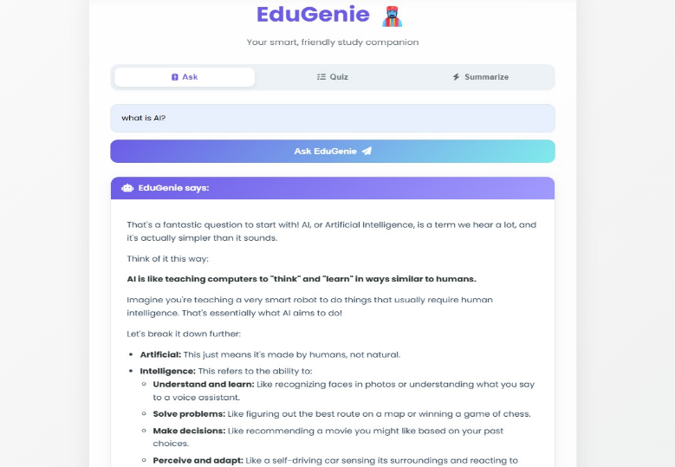
Fig: AI responses generated accurately.
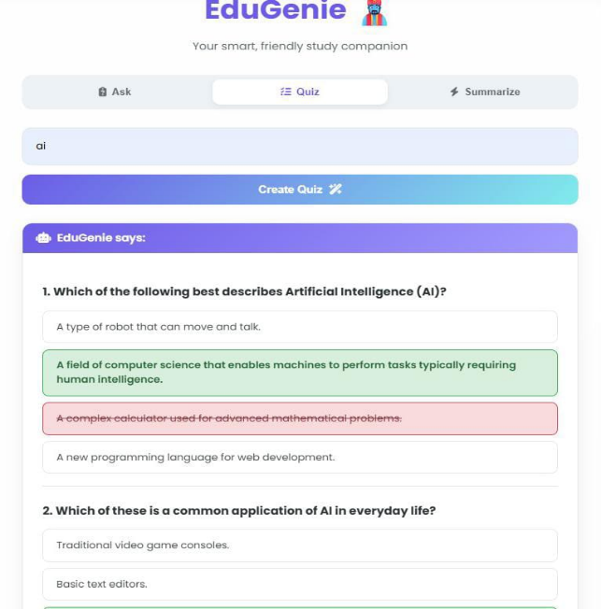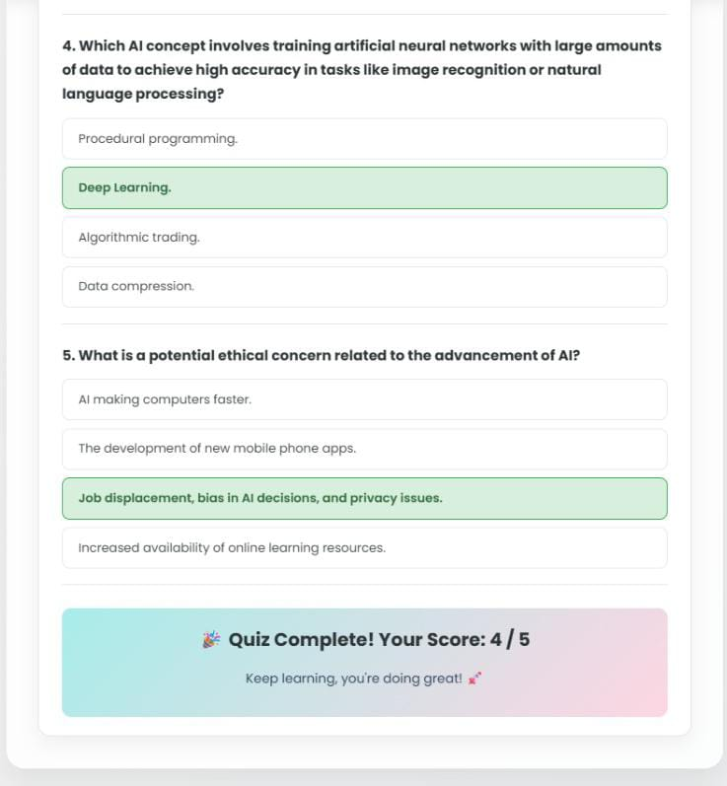
Fig: Quiz interaction works smoothly.
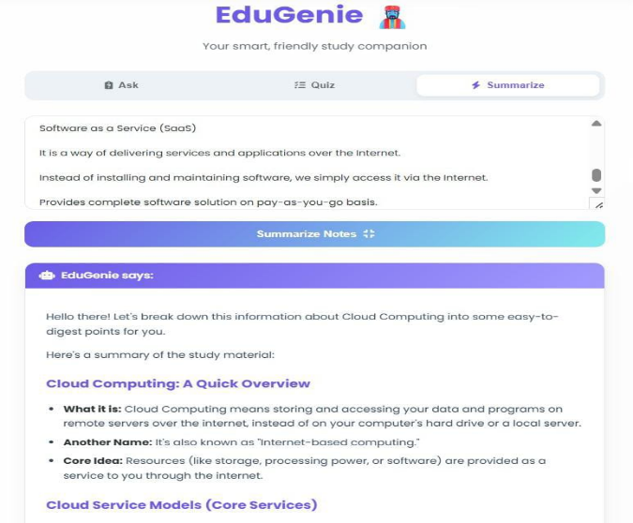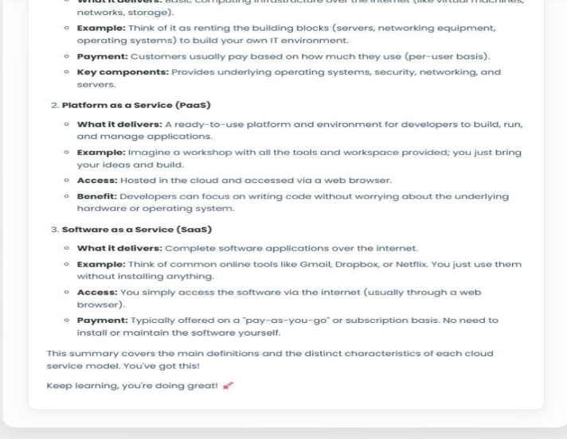
Fig: Summaries are concise and readable.
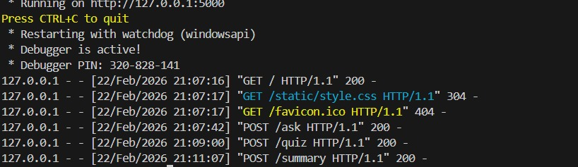
Fig: Code Execution

17. ADVANTAGES & LIMITATIONS
Advantages
- Personalized learning support
- Saves study time
- Interactive experience
- Easy to use interface
Limitations
- Requires internet access
- Depends on API availability
- No persistent user data storage

18. FUTURE ENHANCEMENTS
- Student login and progress tracking
- Voice-based interaction
- Mobile application version
- Cloud deployment
- Adaptive learning recommendations

19. CONCLUSION
EduGenie demonstrates how Generative AI can enhance modern education by providing instant explanations, quizzes, and summaries. The project successfully integrates AI with web technologies to create an engaging and practical learning assistant.

20. APPENDIX
- Source Code files
- Configuration (.env)
- Gemini API usage
Used free Gemini API
- GitHub repository link
https://github.com/RoopaShri2612/EduGinie-GenAI-project
- Live demo link

